**Rui Carapinha Computer Vision**

**248728 December Milestone**

1. **Goals yet to accomplish**

* Improve Face Recognition Algorithm
* Make a small interface

1. **Accomplishments**

* Face Detection
* Cut rectangles of the detected face and save it to a .jpg file
* Resize the two images to the same so the program can compare them
* Face Detection Algorithm

1. **Pictures**

* Only accessing the camera

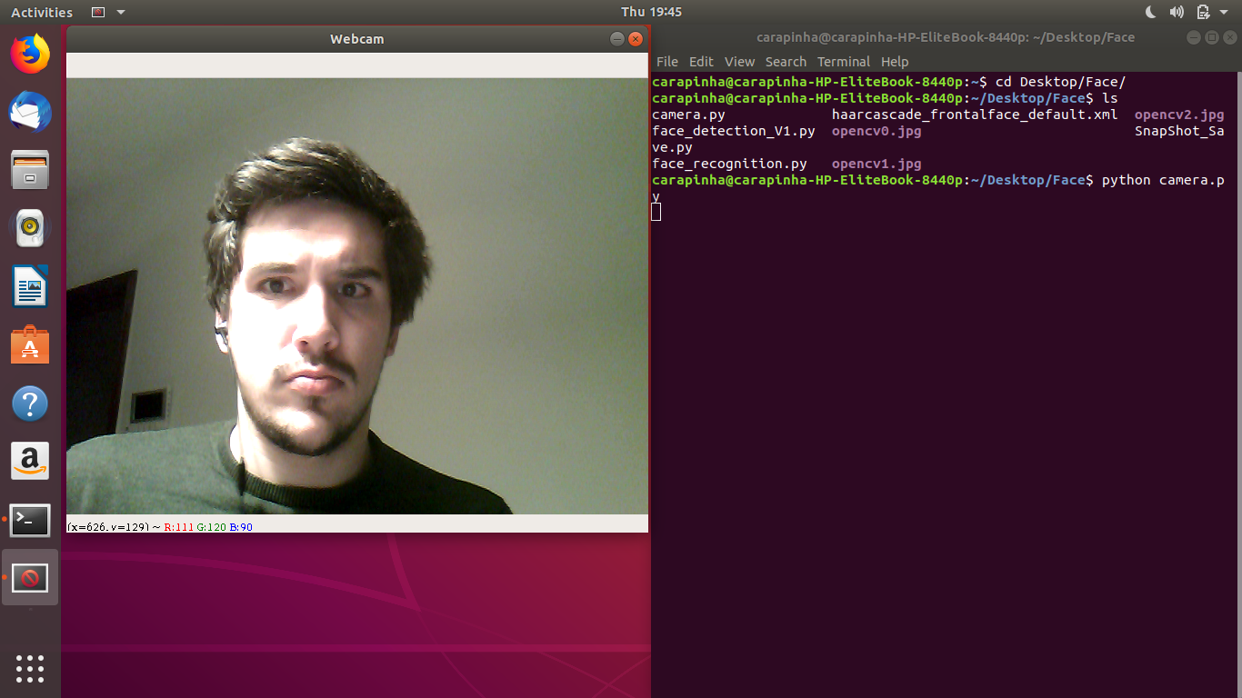

* Face Detection

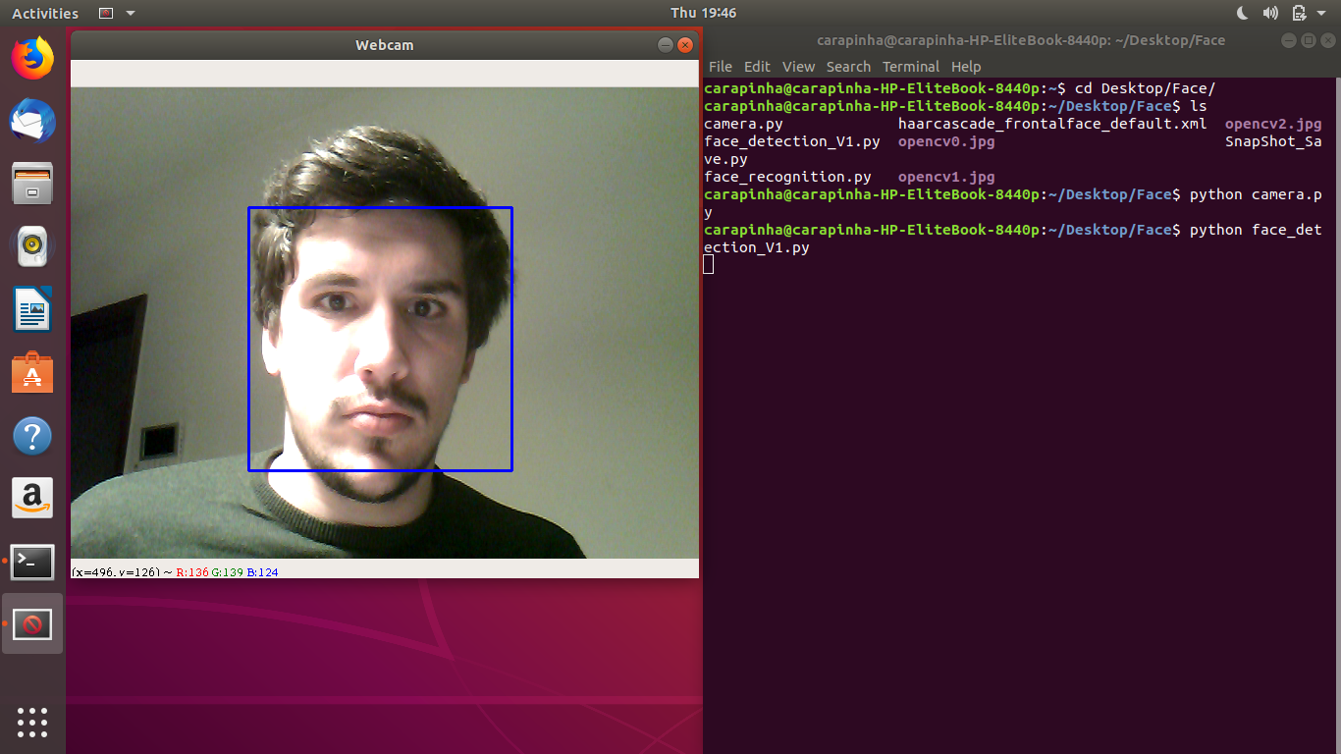

* Face Detection

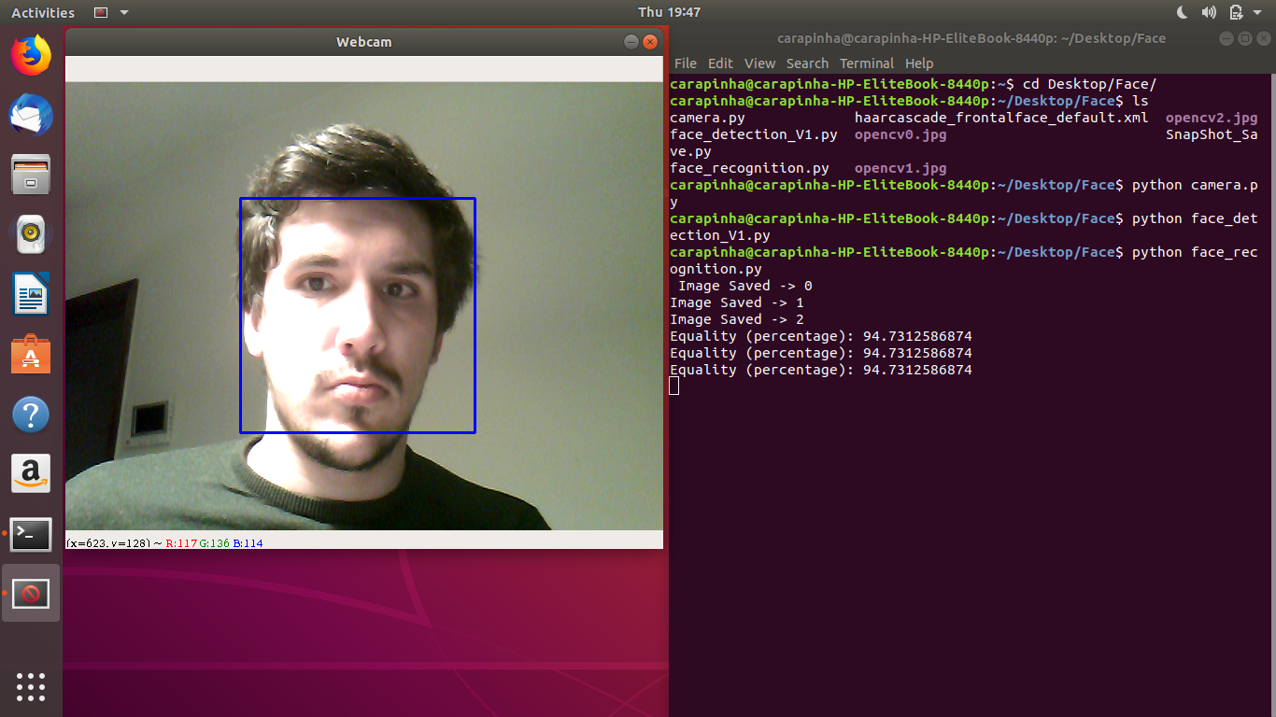

In this last picture we can see that we can take several pictures and them compare them.